EXPERIMENT-4
DESIGN AND IMPLEMENTATION OF MULTIPLEXERS AND DE- MULTIPLEXERS
Aim: Design and implementation of Multiplexers and De-multiplexers
Equipments & Components Required:
IC 7404(NOT GATE), IC 7408(AND GATE), IC 7486(XOR GATE), and IC 7432(OR GATE), Patch cards and IC Trainer Kit.
Theory:
Multiplexer is a combinational circuit that has maximum of 2^{n} data inputs, ‘n’ selection lines and single output line. One of these data inputs will be connected to the output based on the values of selection lines.
Since there are ‘n’ selection lines, there will be 2^{n} possible combinations of zeros and ones. So, each combination will select only one data input. Multiplexer is also called as Mux.
Multiplexers are classified into four types:
a) 2-1 multiplexer (1 select line)
b) 4-1 multiplexer (2 select lines)
c) 8-1 multiplexer(3 select lines)
d) 16-1 multiplexer (4 select lines)

1) 4x1 Multiplexer
4x1 Multiplexer has four data inputs I₃, I₂, I₁ & I₀, two selection lines s₁ & s₀ and one output Y. The block diagram of 4x1 Multiplexer is shown in the following figure.
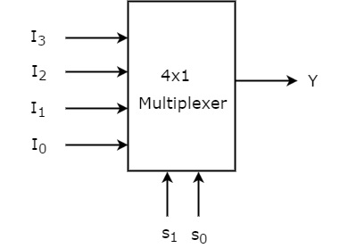
One of these 4 inputs will be connected to the output based on the combination of inputs present at these two selection lines. Truth table of 4x1 Multiplexer is shown below.
Selection Lines |  | Output
S₁ | S₀ | Y
0 | 0 | I₀
0 | 1 | I₁
1 | 0 | I₂
1 | 1 | I₃

From Truth table, we can directly write the Boolean function for output, Y as
Y=S1′S0′I0+S1′S0I1+S1S0′I2+S1S0I3
We can implement this Boolean function using Inverters, AND gates & OR gate. The circuit diagram of 4x1 multiplexer is shown in the following figure.
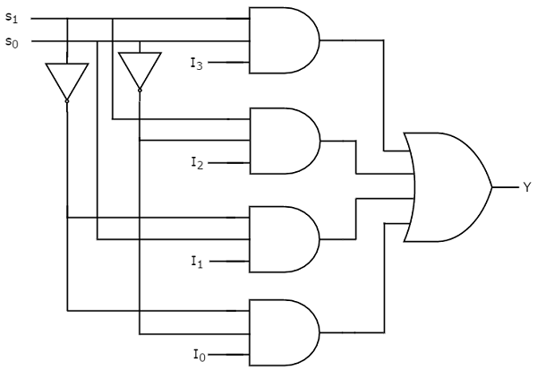

2) De-multiplexer
De-Multiplexer is a combinational circuit that performs the reverse operation of Multiplexer. It has single input, ‘n’ selection lines and maximum of 2^{n} outputs. The input will be connected to one of these outputs based on the values of selection lines.
Since there are ‘n’ selection lines, there will be 2^{n} possible combinations of zeros and ones. So, each combination can select only one output. De-Multiplexer is also called as De-Mux.

1x4 De-Multiplexer
1x4 De-Multiplexer has one input I, two selection lines, s₁ & s₀ and four outputs Y₃, Y₂, Y₁ &Y₀. The block diagram of 1x4 De-Multiplexer is shown in the following figure

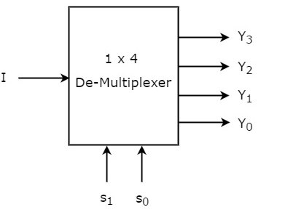
The single input ‘I’ will be connected to one of the four outputs, Y₃ to Y₀ based on the values of selection lines s₁ & s0. The Truth table of 1x4 De-Multiplexer is shown below.
Selection Inputs |  | Outputs
S₁ | S₀ | Y₃ | Y₂ | Y₁ | Y₀
0 | 0 | 0 | 0 | 0 | I
0 | 1 | 0 | 0 | I | 0
1 | 0 | 0 | I | 0 | 0
1 | 1 | I | 0 | 0 | 0

From the above Truth table, we can directly write the Boolean functions for each output as
Y3=s1s0I
Y2=s1s0′I
Y1=s1′s0I
Y0=s1′s0′I
We can implement these Boolean functions using Inverters & 3-input AND gates. The circuit diagram of 1x4 De-Multiplexer is shown in the following figure.
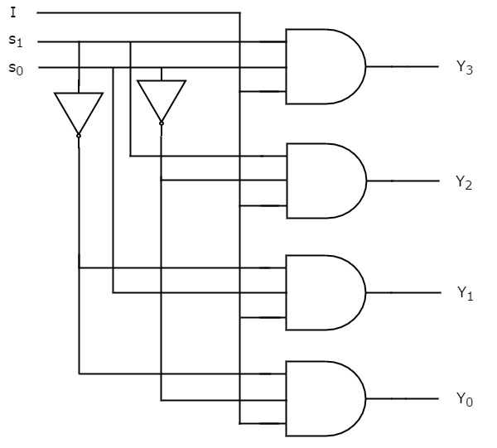
Procedure:
1. Check for the proper working of the gate.
2. Connect the circuit as per circuit diagram.
3. Verify it with truth Table.
Result1: Study of 4*1 multiplexer and verified the truth table.
Result2: Study of 1*4 demux and verified the truth table.
Precaution:
- All IC’s should checked before starting the experiment.
- All the connection should be tight.
- Always connect the ground first and then connect Vcc
- Suitable types of wire should be used for different types of circuit.
- The kit should be off before change the connection.
- After completing the experiment switch off the power supply of apparatus.

